**IN6221 – INFORMATION VISUALISATION**

**Group Assignment**

**Name:** Zhou Gaoqiang, Liao Yuan, Chin Jia Hui, Chia Ang Shen, Guo Kaihua

**Matriculation Number:** G2304064A, G2406558C, G2304521F, G2304562F, G2304650E

**Website Title:** Singapore Transit Triumph | A Journey through Excellence

**Introduction**

Singapore’s journey toward building a world-class public transport system showcases the success of strategic planning and continual adaptation. In the 1970s and 1980s, rapid urbanization and population growth placed immense pressure on road infrastructure, promoting Singapore to prioritised investment in public transportation network (Lim, n.d.). Initiatives such as the development of the MRT system and the emphasis on interconnected transport services have transformed Singapore into a model of urban mobility, achieving both efficiency and environmental sustainability.

Today, Singapore's public transport infrastructure continues to evolve, blending policy and technology to meet the increasing population demands. Despite occasional incidents, like the recent MRT East-West Line disruption impacting 2.1 million passengers in September 2024 (Loi & Khan, 2024), Singapore's system remains globally recognised for its reliability and innovation. The Urban Mobility Index’s 2023 by Oliver Wyman Forum ranked Singapore at third place worldwide (Urban Mobility City Rankings, n.d.) . This is a testament to the city state’s efforts and highlights Singapore’s commitment to continuously improve urban mobility and reduce traffic congestion.

This success also reflects the integration of policies such as congestion pricing, fleet management, and regular updates to infrastructure, which serve as benchmarks for other cities aiming to build sustainable and resilient urban transport systems.

**Problem Statement**

Despite Singapore’s public transportation network being one of the most advanced globally, the public in Singapore may not be fully aware of the system’s historical growth and achievements. Currently, there is no comprehensive single source online resource that details the system's transformation over the decades. The information about Singapore's public transport history and key developments is fragmented, difficult to locate, and lacks visual appeal. This gap limits public appreciation for the technological advancements that contributed to Singapore’s world class status. Moreover, with recent MRT technical incidents, the need for transparent, accurate information on the system's resilience and ongoing improvements has become even more critical.

The website and visualisation charts provide a comprehensive overview of Singapore’s public transport evolution, helping foster a deeper understanding of its commitment to sustainable urban mobility.

**Data Collection**

The data for the website are sourced from official Singapore government websites – Land Transport Authority DataMall (LTA DataMall) and the Singapore Department of Statistics ([Dataset], n.d.). These official sites provide high-quality and reliable data on the rail network length, ridership population, vehicle population, and service delays, forming the foundation of the charts displaying the key trends of Singapore’s public transport system.

**Tools**

The website development employed a variety of tools to create a functional, and visually engaging user experience. Here’s a breakdown of the core technologies and tools utilised:

**Web Development Core Technology:**

* **HTML:** Forms the foundation structure and content for information presentation.
* **CSS:** Styles and positions elements to create an aesthetically pleasing layout.
* **JavaScript:** Adds responsiveness and interactivity for enhanced user engagement.

**Libraries:**

* **D3:** Creates custom, responsive charts to present complex data visually.
* **Bootstrap:** Utilises its pre-designed classes and elements to accelerate layout and component development.
* **AOS (Animate On Scroll):** Adds animation effects triggered by scrolling, spotlighting key sections and adds visual dynamics to the website.
* **Swiper:** Enables responsive sliders and smooth transition for images and charts carousels.
* **PureCounter:** Display animated counters to showcase impactful statistics.

**Development and Image Editing Tools:**

* **VS Code:** Provides robust development and editing functions for efficient coding and debugging.
* **Chrome:** Used for testing and debugging to ensure website performance.
* **GitHub:** Allows version control and collaboration for code hosting to streamline team workflow.
* **Photoshop:** Editing image and design elements to polish website visuals.

**Elements and Application of Theories**

The website integrates different design elements, theories and chart designs to deliver a visually appealing, well-organized, and informative experience for users. Here is the overview of the design elements and theories of the website's layout, functionality, and visual appeal:

**Design Elements**

* **Colour:** According to DesignMantic, the colour green conveys sustainability and brown conveys dependability and reliability when designing elements relating to transport (Brown, n.d.). Hence, the website uses a colour palette consisting of primary colours dark green and dark brown, and secondary colours of light green, light brown, off white, grey and black to compliment the visuals. This colour choice aligns with the image that Singapore’s public transport system’s wants to convey – a reliable world class system that is reliable and sustainable. The primary colour dark green is used in the main headers, while dark brown is used on the statistics to illustrate the stellar performance of Singapore’s public transport system. Where appropriate, the secondary colours are used in charts to create contrast.
* **Space:** Negative space is used throughout the website to optimise readability and navigation. Ample space is provided around content and elements to allow users to focus on the information in each section without visual clutter. In addition, each section’s background alternates between white and grey to clearly segment the information illustrated.
* **Shapes – Stylization:** Minimalism is used throughout the website to bring focus to the charts which is the main message to convey.
* **Typography:** Sans-serif font is chosen to enable general readability and provides a clean and modern look. Different font sizes are used to differentiate headers, sub headers, and body text, managing information density at each section. The headers like “Our Public Transport” and “Journey Through Decades” are in upper caps with larger and bold font to stand out from the rest of the paragraph. This visual hierarchy guides users through the content intuitively.
* **Value:** Lighter values are mainly used on the website to convey a brighter and positive message. Darker values are used selectively on headers and statistics to show contrast and emphasise the importance for those elements.
* **Line direction:** Different chart visualisations such as line charts, racing bar charts and area charts are used show trend over time. The section below on chart design discusses the design philosophy behind the charts against the information it meant to illustrate.

**Design Theories**

* **Gestalt Principles**
  + **Proximity:** The website incorporates the proximity rule by grouping related information together into 4 sections – Overview, Our History, Key Trends, and Our Future. For example, the “Growth On Track” section groups all the charts so users can follow the flow and linkage between the data visualisations. This visual grouping saves users time searching for related info and makes navigation feel intuitive and sections easier to follow.
  + **Similarity:** Consistency is used in design elements like fonts, colours, shapes, and charts to create structure and a sense of continuity. Dark green and dark brown are used for more important information like the headers and charts while the lighter colour values are used to compliment the design.
* **KISS (Keep it Simple, Stupid) Principle:**  The design follows the KISS principle with a clean and simple approach, with no unnecessary elements to distract. Clear lines, short text, and limited colours avoid visual noise and direct users to focus on the content. The navigation bar allows users to jump between sections like “Overview” and “Key Trends” to get the information they require. This simple layout highlights the data visualisation without injecting overwhelming elements.
* **Responsive Design Principle:** The site responsive uses Bootstrap’s grid system to adapt content for various screen sizes. On larger screens, the “Overview” and “Journey Through Decades” sections display in a multi-column layout and collapses to a single-column layout on mobile to preserve readability and accessibility. The navigation bar collapses into a mobile menu on smaller screens so users can access the menu without taking up too much screen real estate. With images that auto-resize and adaptive navigation, the site works across all devices from desktop to smartphone as expected of modern web design for a seamless multi-device experience.

**Chart Designs**

All the charts in this website are time series charts to illustrate trend over time, with a variety of chart types being used to drive home the story we want to bring across for each trend. Each of the charts has a chart title to clearly state the objective of the chart, axis labels to provide context and identification of data on the respective axis, and a legend to match the visual to the data category. The main charts are grouped together under the “Growth on Track” section for better storytelling. Below is the breakdown of the chart designs and the rationale behind the choice:

* **Singapore Population and Rail Network Length Charts (Figure 1):**
  + **Chart Type:** Line charts
  + **Purpose:** Line charts demonstrate overall growth and rate of change over time. In particular, the rail network length line chart shows the relationship between the data series. The lines depict the accelerated growth of the MRT system relative to the LRT.
  + **Design Elements:** Hover-over description box provide additional insights to allow users to explore details without crowding the chart. In the rail network length chart, each line represents a different data series, such as MRT and LRT rail lengths, and is illustrated with different colours.

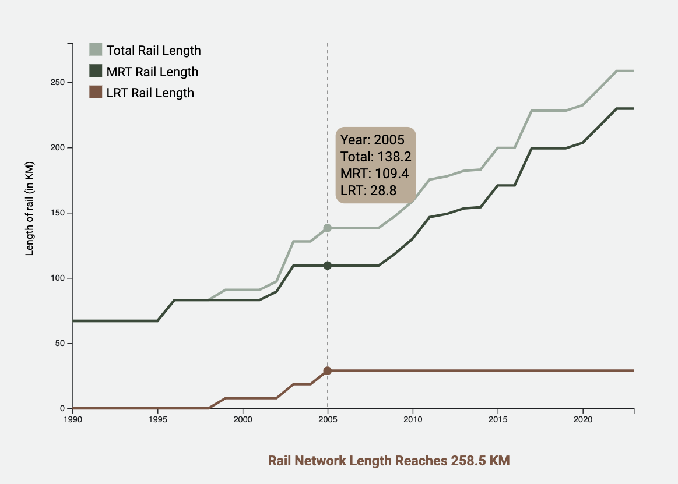*Figure 1. Chart Illustrating Rail Network Length Growth*

* **Ridership Number Chart (Figure 2):**
  + **Chart Type:** Racing Bar Chart
  + **Purpose:** A racing bar chart helps to visualise the ranking and rapid growth in ridership numbers across different transport modes, highlighting shifts in public preferences. The animation captures the shifts in ranking over time, which makes it engaging and effective to illustrate the dynamic changes in transport preferences.
  + **Design Elements:** Animated bars show position changes dynamically, making it easy to observe key milestones, like the moment when taxis overtook LRT. Dark green and brown are used for MRT and buses to emphasise their significance, while light green and brown represent taxis and LRT which are secondary transport modes. Mode-specific images in the bars help with identification of the categories.

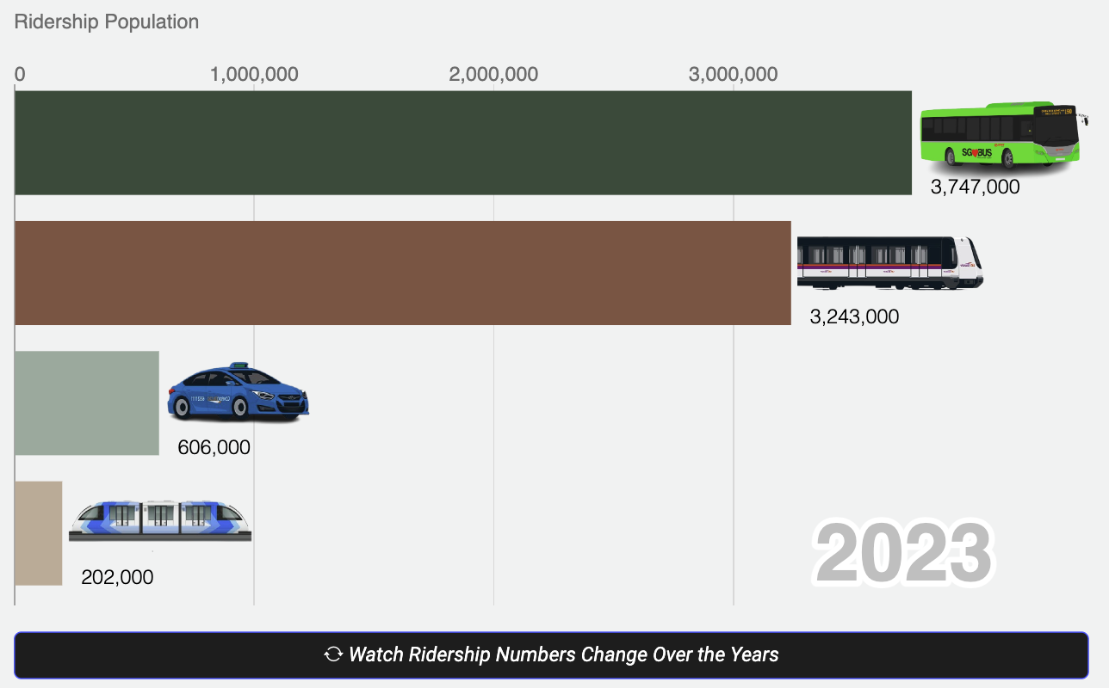

*Figure 2. Chart Illustrating Transport’s Ridership Population Growth*

* **Public Motor Vehicle Population Chart (Figure 3):** 
  + **Chart Type:** Area Chart
  + **Purpose:** An area chart shows the changes in vehicle population over time and reveal the general volume and trend without focusing on precise numbers.
  + **Design Elements:** The chart shows the overall trend, while the hover-over description box is an interactive element that provides a detailed breakdown for users who want to explore the data.

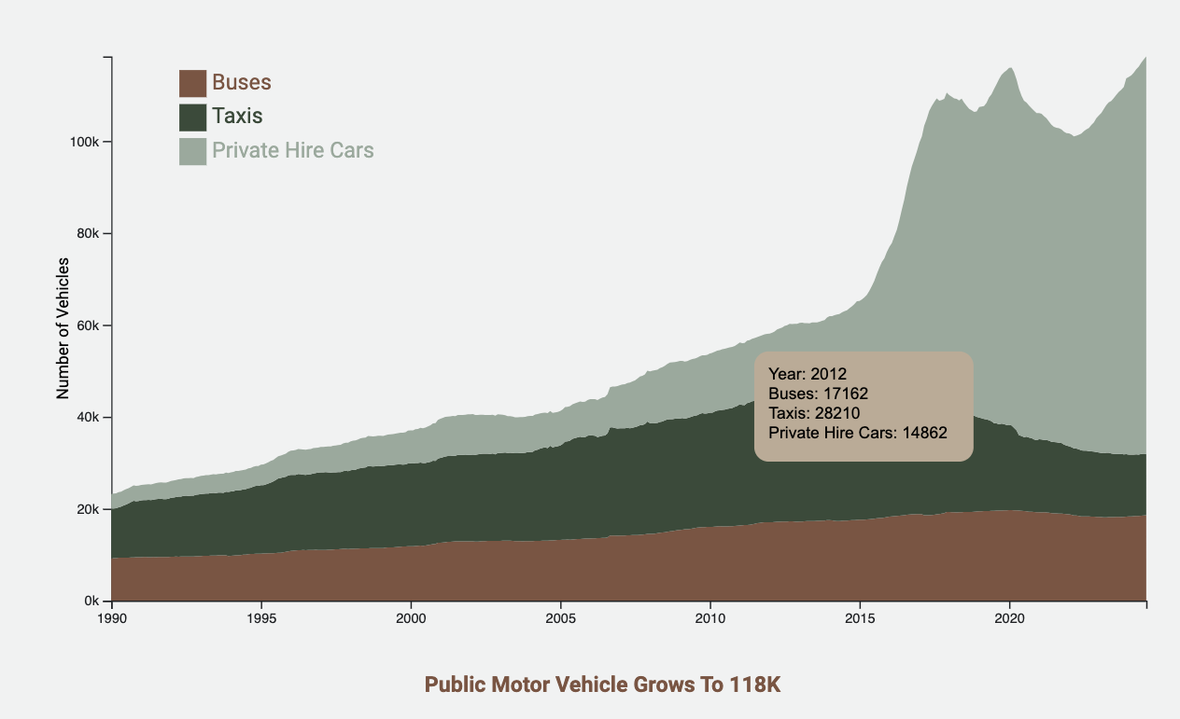

*Figure 3. Chart Illustrating Public Motor Vehicle Population Growth*

* **Rail Service Delays Chart (Figure 4):**
  + **Chart Type:** Treemap
  + **Purpose:** A treemap represents the number and proportion of service delays across multiple rail lines, making it easier to identify broad patterns in service performance. Given the high number of categories, the treemap organises them so users can see the trends, such as the decline in service delays and the lines affected, without being overwhelmed.
  + **Design Elements:** Different-sized boxes show the frequency and impact of delays, with larger boxes representing more significant values. Colour opacity varies to draw attention to the pattern rather than specific categories.

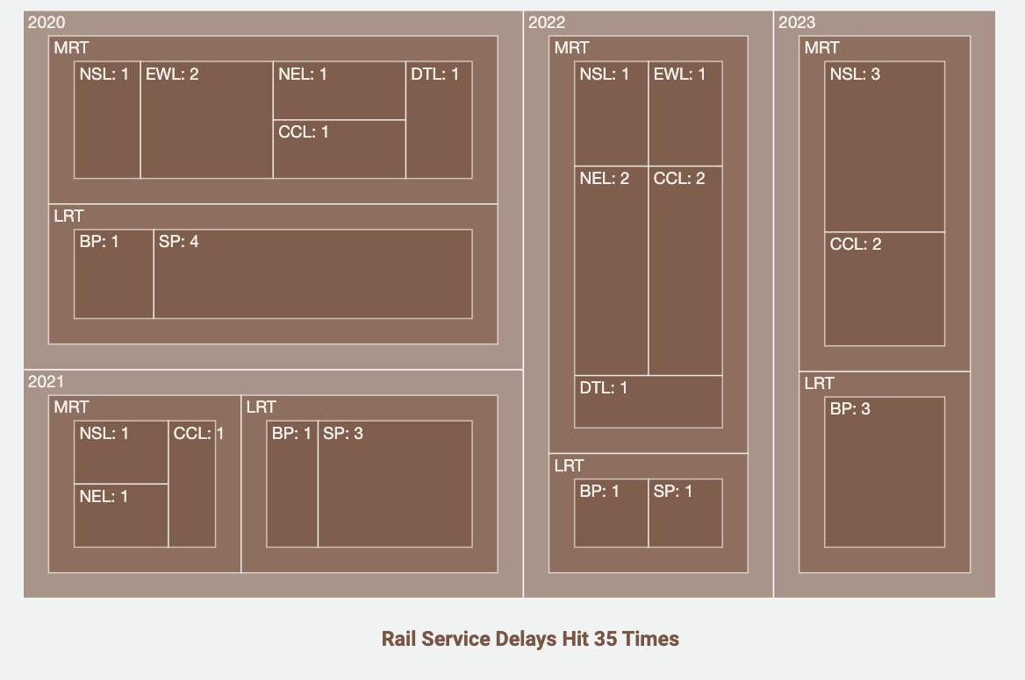*Figure 4. Chart Illustrating Rail Service Delays with > 30min Delay*

**Evaluation and Conclusion**

The "Singapore Transit Triumph" website successfully achieves its main objectives of educating the public on the evolution of Singapore’s public transport system and fostering a deeper appreciation for its achievements and resilience. By providing a centralized and visually appealing platform, it brings together information that was previously fragmented across various sources, offering users a comprehensive view of the system's growth, accomplishments, and ongoing advancements.

The site’s use of data visualizations, guided by thoughtful design theories and elements, transforms complex trends into accessible and engaging insights. The carefully selected color palette, strategic spacing, and typographic hierarchy reinforce themes of sustainability and reliability, enhancing readability and user experience. Through interactive elements and a user-centered approach, the site makes it easy for users to navigate the narrative of Singapore’s journey toward public transport excellence.

In conclusion, by merging clear design principles with compelling data visualizations, "Singapore Transit Triumph" effectively showcases the city-state’s dedication to sustainable urban mobility, positioning itself as a valuable resource for anyone interested in the evolution of one of the world’s most efficient transit systems.

**Reference**

Brown, E. (n.d.). *The 7 Colors Of The Carrier: Color Matters In Transport Logo Design*. https://www.designmantic.com/blog/color-matters-transport-logo/amp/

[Dataset]. (n.d.). [Dataset]. https://datamall.lta.gov.sg/content/datamall/en.html

[Dataset]. (n.d.). [Dataset]. https://www.singstat.gov.sg/

Lim, T. S. (n.d.). *Area Licensing Scheme*. National Library Board.

Loi, E., & Khan, F. (2024, January 10). East-West Line MRT services back to normal after 6-day disruption. *The Straits Times*.

*Urban Mobility City Rankings*. (n.d.). OliverWyman Forum.

**Website Screenshots**

